Write a program for DFS using python code

Aim :To implement the Depth-First Search (BFS) algorithm using Python.
Procedure:
Create a graph using an adjacency list.
Start traversal from the source node.
Visit the node and mark it as visited.
Recursively visit all unvisited adjacent nodes.
Continue until all reachable nodes are visited.

Output:
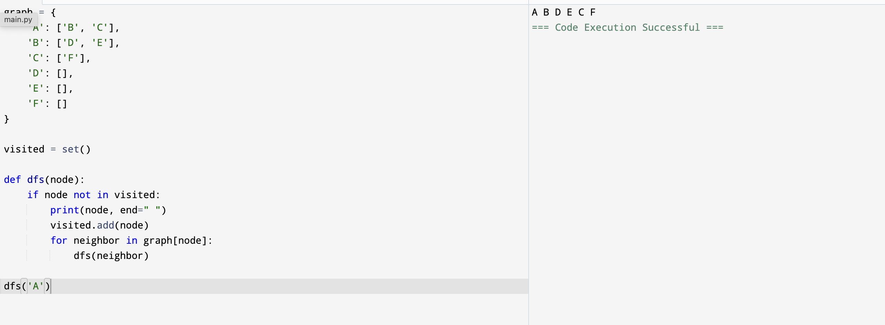

Result: Hence, DFS problem has solved

